SOWTER TYPE U058  PUSH-PULL OUTPUT TRANSFORMER  for EL34 FIXED BIAS  Rl = 3500 Ohms | PACKAGE | PACKAGE OPTIONS | PART NUMBER
 | SIZE "L"  3.1 Kg | Fully shrouded | U058-S
 | SIZE "L"  3.1 Kg | Drop through | U058-T
 | SIZE "L"  3.1 Kg | Open frame | U058-O
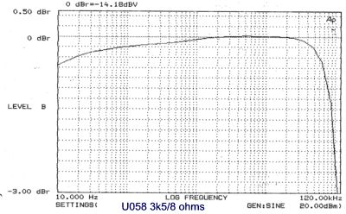 | 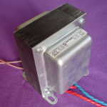
APPLICATION A robustly designed Push-Pull output transformer for use with two El34 or similar valves. Power rating specified at 50 Hz for guitar use. Replacement part for VOX AC50.
FEATURES 1 inch Grain Oriented (M6) laminated core for minimal losses and distortion. 14 section interleaved primary and secondary windings to give excellent bandwidth. Two chamber bobbin ensures full capacity and resistance balance to eliminate distortion caused by transformer unbalance. Low copper resistance to minimize losses and maximize loudspeaker damping. Single 8 ohm secondary windings. Other secondary configurations can be selected at time of order.
POWER RATING | 65 Watts at 50 Hz.
 | Primary |  | Secondary
Nominal winding impedance | 3500 ohms |  | 8 ohms
Inductance | 36.7 H |  | 2.4 mH
DC Resistance | 68 ohms |  | 0.2 ohms
Leakage inductance | 1.92 mH ref primary
DC current per side | 130 mA max
Ratio (8 ohm configuration) | 20.92 :1
Bandwidth | 10 Hz to 100 KHz (-3 dB points typical)
Total Harmonic Distortion | 0.05 % at 1 kHz full power
CONNECTIONS | 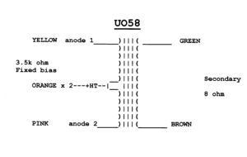

E A Sowter Ltd
The Boatyard, Cullingham Road
IPSWICH IP1 2EG England

Tel: +44(0)1473 252794
Fax: +44(0)1473 236188
E-Mail sales@sowter.co.uk

